October 14, 2015 |  |  | 1
 | Sponsor: | Dembowski
[pdc]
 | Proposed No.: | 2015-0350
AMENDMENT TO PROPOSED ORDINANCE 2015-0350, VERSION 1
On page 2, after line 25, insert:
"6. The proposed changes will have significant impacts on transit riders and will require many riders to transfer. To ensure that impacts on transit riders are understood and can be addressed in future service changes as needed, the Council bases its approval of the proposed changes on direction to Metro to prepare a work plan on its work to make transfers convenient, safe and accessible, as described in Section 2 of this ordinance; a presentation on its joint public engagement campaign focused on customer education and assistance to help riders identify new travel options using the restructured Metro bus network, as described in Section 3 of this ordinance; a work plan identifying customized performance measures for and customer satisfaction with the routes and corridors affected by the restructure, as described in Section 4 of this ordinance; and a traffic impact analysis for a proposed new bus stop at the University of Washington light rail station, as described in Section 5 of this ordinance.
On page 3, after line 31, insert:
"SECTION 2. Consistent with the King County Metro Service Guidelines, Metro considers as part of its network planning locations where transfer opportunities could be provided and where provision of convenient transfers could improve the efficiency of the network. Metro strives to make transfers convenient, safe and accessible, and to work with partners to provide safe environments for pedestrians in a manner consistent with the goals of the City of Seattle Vision Zero Safer Streets for Seattle initiative. In order to help facilitate connections in locations where passenger transfers are expected to increase due to the proposed changes, the executive is directed to work with Sound Transit, the University of Washington and the city of Seattle to improve the transfer environment in such locations. Locations where transfers are expected to increase as a result of the proposed changes include, but are not limited to NE Northgate Way and Roosevelt Way NE, Roosevelt Way NE and NE 65th Street, NE Ravenna Boulevard and NE 65th Street, 25th Avenue NE and NE 65th Street, NE Campus Parkway and University Way NE, 19th Avenue E and E Madison Street, 23rd Avenue E and E Madison Street, and near the new Capitol Hill and University of Washington light rail stations, including each of the bus stops planned near the University of Washington light rail station. A number of transfer locations are shown in Attachment B to this ordinance, Key Transfer Locations map. Amenities or treatments that would improve the transfer environment include, but are not limited to, shelters, lighting, benches, trash receptacles, wayfinding signage, digital signboards, customer information, crosswalks and changes to signalization.
The executive shall submit to the council a work plan describing specific improvements planned for each of these transfer areas and a timeline for implementation that shall include plans to be implemented by March 2016, as well as plans to be implemented during the course of 2016 and plans to be implemented between 2017 and 2020. The work plan shall identify the responsible party and funding source for each planned improvement and shall include any legislation needed to implement the improvements. These improvements shall be implemented as expeditiously as possible to help achieve the objectives of safe and accessible transfer environments. When transmitted to the council, the work plan shall be accompanied by a motion to approve the work plan. The executive shall transmit the work plan and motion by January 29, 2016, in the form of a paper original and an electronic copy with the clerk of the council, who shall retain the original and provide an electronic copy to all councilmembers, the council chief of staff, the policy staff director and the lead staff for the transportation, economy and environment committee, or its successor.
SECTION 3. A. To ensure successful implementation of and the highest possible customer satisfaction with the University Link bus integration project, the executive is directed to work with Sound Transit, the city of Seattle, the University of Washington and other stakeholder organizations to carry out a joint public engagement campaign focused on customer education and assistance to help riders identify new travel options using the restructured Metro bus network, the Central Link Light Rail, and Sound Transit Express bus routes.
B. The executive shall provide an oral report on the joint public education campaign plans to the transportation, economy and environment committee no later than the first regular December 2015 meeting of the committee, with subsequent monthly presentations to the committee if requested by the chair of the committee. The report shall address, but not be limited to:
1. Plans to provide advance notice to current and potential riders about:
a. changes in bus route alignments, frequency and span;
b. transfer opportunities;
c. projected travel times; and
d. resources to obtain more information on the service change;
2. Plans to encourage and assist eligible individuals to enroll in discounted ORCA fare products including the ORCA LIFT card, youth fare and the Regional Reduced Fare Permit for senior/disabled riders;
3. Plans to inform eligible individuals about community access transportation options, including but not limited to the Hyde Shuttle and partner agency transportation services supported by Metro;
4. Use of residential mailings, advertisements, technology and public events to conduct outreach, including strategies to reach individuals with no access to the Internet;
5. Proposed activities for the initial service period including publicity, ORCA registration opportunities, incentives, street team activities, response to immediately identified problems and coordination among the participating agencies; and
6. Costs of the joint campaign and how the costs are proposed to be allocated among the agencies.
SECTION 4. A. To ensure a full understanding of the ridership impacts and customer response to the University Link bus integration service change, by January 29, 2016, the executive shall transmit a work plan, and a motion for the approval of the work plan, identifying customized performance measures for the routes and corridors affected by the restructure. The work plan shall:
1. Identify performance measures to assess ridership and customer satisfaction with the existing Metro bus network and the new network integrated with the Central Link light rail;
2. Include plans through which the division shall conduct a customer and resident service assessment survey to be conducted by March 2017 to measure customer and resident satisfaction prior to and following the service change;
3. Be coordinated with Sound Transit performance assessments to avoid duplication of effort; and
4. Be modeled on past performance reports such as the C and D Line assessment.
B. The council is interested in near-term assessments of the service change impacts but recognizes that a thorough evaluation must take place over an extended time period.
C. The executive shall transmit the report in the form of a paper original and an electronic copy with the clerk of the council, who shall retain the original and provide an electronic copy to all councilmembers, the council chief of staff, the policy staff director and the lead staff for the transportation, economy and environment committee, or its successor.
SECTION 5. To ensure a full understanding of the potential traffic impacts in the vicinity of the University of Washington light rail station, prior to the installation of a bus stop on Montlake Boulevard NE near Hec Edmundson Pavilion, the council must pass a motion approving a report to be transmitted by the executive. The report shall summarize the results of a traffic impact analysis of a new bus stop on Montlake Boulevard NE near Hec Edmundson Pavilion with an assessment of the impact of that stop on general purpose traffic travel time on Montlake Boulevard NE from Boyer Avenue East to NE 45th Street and impact on the level of service and performance of intersections at Montlake Boulevard NE with NE Pacific Street and NE Pacific Place. The executive shall transmit the report and motion in the form of a paper original and an electronic copy with the clerk of the council, who shall retain the original and provide an electronic copy to all councilmembers, the council chief of staff, the policy staff director and the lead staff for the transportation, economy and environment committee, or its successor."
In Attachment A, the clerk shall make the following edits, change the date, and revise page numbers accordingly.
On pages 2, 20, 23, 26, 32, 35, 38, 41, 44, 50, 56, 62, 68, 71, 78, and 83, delete:
"
- Strategic Plan Strategy 3.2.1: Expand services to accommodate the region's growing population and serve new transit markets. Coordinate and develop services and facilities with other providers to create an integrated and efficient regional transportation system."
and insert:
"
- Strategic Plan Strategy 3.2.1: Expand services to accommodate the region's growing population and serve new transit markets.
- Strategic Plan Strategy 3.2.2: Coordinate and develop services and facilities with other providers to create an integrated and efficient regional transportation system."
Delete pages 29, 30 and 31 pertaining to Route 43 and insert two new pages .

ROUTE: 43

OBJECTIVES:
Alternative service to Route 43 will be provided by routes 8, 10, 11, 12, 47, 49, and revised Route 48.

Restructure and integrate service to complement the extension of Sound Transit Link light rail service to Capitol Hill and the University of Washington, in accordance with the Strategic Plan for Public Transportation, 2011-2021 and King County Metro Service Guidelines:

- Strategic Plan Strategy 3.1.1: Through investments and partnerships with regional organizations, local jurisdictions and the private sector, provide alternatives to driving alone.
- Strategic Plan Strategy 3.2.1: Expand services to accommodate the region's growing population and serve new transit markets.
- Strategic Plan Strategy 3.2.2: Coordinate and develop services and facilities with other providers to create an integrated and efficient regional transportation system.
- Strategic Plan Strategy 3.4.1: Serve centers and other areas of concentrated activity, consistent with Transportation 2040.

- Strategic Plan Strategy 5.1.1: Provide service that is easy to understand and use.

- Strategic Plan Strategy 6.1.1: Manage the transit system through service guidelines and performance measures.
  - Service Design Guideline – Routes should be designed in the context of the entire transportation system.
  - Service Design Guideline – A route that operates directly between two locations is faster and more attractive to riders than one that takes a long, circuitous path.
  - Service Design Guideline –Routes should serve connection points where riders can connect to frequent services, opening up the widest possible range of travel options.
  - Service Design Guideline – Routes are more efficient when designed to serve multiple purposes and destinations rather than specialized travel demands.

IMPACTED SERVICE AREA:
University District, Montlake, Capitol Hill, Seattle CBD
SERVICE CHANGE:

Eliminate off-peak and night service on Route 43 on weekdays, Saturdays and Sundays. Reduce service frequency during peak periods to about every 30 minutes. Alternative service along Montlake Place East, 23rd Avenue East and 24th Avenue East, will be provided by Route 12 or revised Route 48. Alternative service along East Thomas Street and East John Street will be provided by revised routes 8 and 11. Alternative service along Pike Street and Pine Street will be provided by routes 10, 11, 47, and 49.

Delete pages 47 and 48 pertaining to Route 65 and insert two new pages.

ROUTE: 65

OBJECTIVES:
Restructure and integrate service to complement the extension of Sound Transit Link light rail service to Capitol Hill and the University of Washington, in accordance with the Strategic Plan for Public Transportation, 2011-2021 and King County Metro Service Guidelines:

- Strategic Plan Strategy 3.1.1: Through investments and partnerships with regional organizations, local jurisdictions and the private sector, provide alternatives to driving alone.
- Strategic Plan Strategy 3.2.1: Expand services to accommodate the region's growing population and serve new transit markets.
- Strategic Plan Strategy 3.2.2: Coordinate and develop services and facilities with other providers to create an integrated and efficient regional transportation system.
- Strategic Plan Strategy 3.4.1: Serve centers and other areas of concentrated activity, consistent with Transportation 2040.
- Strategic Plan Strategy 5.1.1: Provide service that is easy to understand and use.

- Strategic Plan Strategy 6.1.1: Manage the transit system through service guidelines and performance measures.
  - Service Design Guideline – Routes should be designed in the context of the entire transportation system.
  - Service Design Guideline – A route that operates directly between two locations is faster and more attractive to riders than one that takes a long, circuitous path.
  - Service Design Guideline –Routes should serve connection points where riders can connect to frequent services, opening up the widest possible range of travel options.
  - Service Design Guideline – Routes are more efficient when designed to serve multiple purposes and destinations rather than specialized travel demands.

IMPACTED SERVICE AREA:
Jackson Park, Lake City, Wedgwood, Ravenna, Bryant, University District
SERVICE CHANGE:

Improve midday frequency on Route 65 to about every 15 minutes on weekdays and Saturdays. A routing revision through the University District will connect Route 65 to the new University of Washington light rail station.
The Route 65 may not serve a bus stop on the east side of Montlake Boulevard NE within one-half mile of the University of Washington light rail station until the Council has adopted a motion approving the report referenced in Section 5 of this ordinance.

Delete pages 53, 54 and 55 pertaining to Route 67 and insert three new pages.

ROUTE: 67

OBJECTIVES:
Restructure and integrate service to complement the extension of Sound Transit Link light rail service to Capitol Hill and the University of Washington, in accordance with the Strategic Plan for Public Transportation, 2011-2021 and King County Metro Service Guidelines:

- Strategic Plan Strategy 3.1.1: Through investments and partnerships with regional organizations, local jurisdictions and the private sector, provide alternatives to driving alone.
- Strategic Plan Strategy 3.2.1: Expand services to accommodate the region's growing population and serve new transit markets.
- Strategic Plan Strategy 3.2.2: Coordinate and develop services and facilities with other providers to create an integrated and efficient regional transportation system.
- Strategic Plan Strategy 3.4.1: Serve centers and other areas of concentrated activity, consistent with Transportation 2040.
- Strategic Plan Strategy 5.1.1: Provide service that is easy to understand and use.

- Strategic Plan Strategy 6.1.1: Manage the transit system through service guidelines and performance measures.
  - Service Design Guideline – Routes should be designed in the context of the entire transportation system.
  - Service Design Guideline – A route that operates directly between two locations is faster and more attractive to riders than one that takes a long, circuitous path.
  - Service Design Guideline –Routes should serve connection points where riders can connect to frequent services, opening up the widest possible range of travel options.
  - Service Design Guideline – Routes are more efficient when designed to serve multiple purposes and destinations rather than specialized travel demands.

IMPACTED SERVICE AREA:
Northgate, Pinehurst, Maple Leaf, Roosevelt, University District

SERVICE CHANGE:

Revise Route 67 to serve Roosevelt Way Northeast north of Northeast 80th Street. Route 67 will also be revised to serve Northeast Pacific Street to connect to the new University of Washington light rail station. Frequency will be improved on weekdays to about 10-15 minutes during peak periods, and about every 15 minutes during the midday and every 15-30 minutes at night. Weekend service will also be introduced, with service about every 15-30 minutes on Saturdays and about every 30 minutes on Sundays. New Route 63 and revised Route 67 will provide alternative service north of the University District.
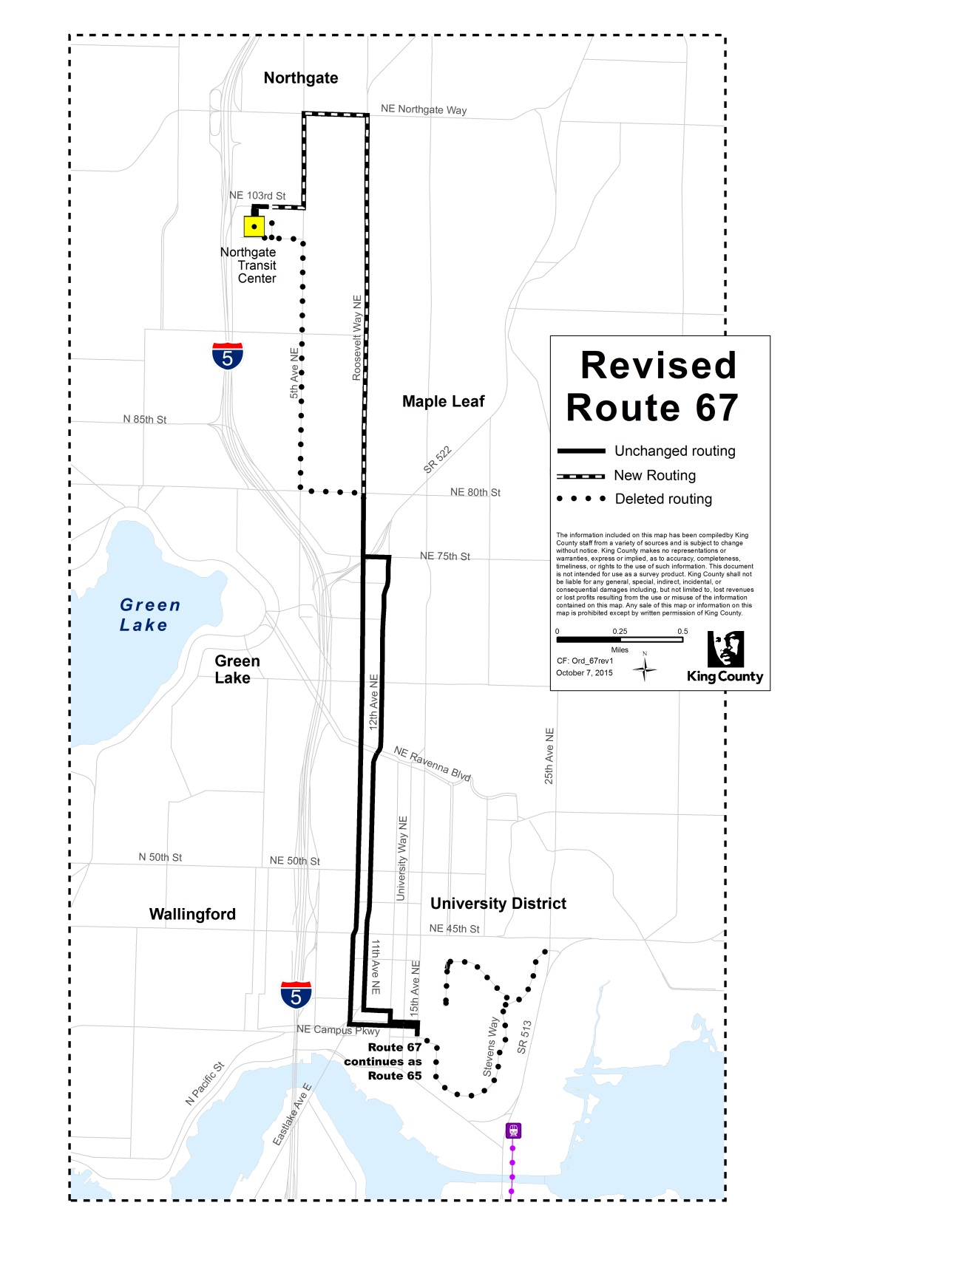

Delete pages 59, 60 and 61 pertaining to Route 71 and insert three new pages.
ROUTE: 71

OBJECTIVES:
Restructure and integrate service to complement the extension of Sound Transit Link light rail service to Capitol Hill and the University of Washington, in accordance with the Strategic Plan for Public Transportation, 2011-2021 and King County Metro Service Guidelines:

- Strategic Plan Strategy 3.1.1: Through investments and partnerships with regional organizations, local jurisdictions and the private sector, provide alternatives to driving alone.
- Strategic Plan Strategy 3.2.1: Expand services to accommodate the region's growing population and serve new transit markets.
- Strategic Plan Strategy 3.2.2: Coordinate and develop services and facilities with other providers to create an integrated and efficient regional transportation system.
- Strategic Plan Strategy 3.4.1: Serve centers and other areas of concentrated activity, consistent with Transportation 2040.
- Strategic Plan Strategy 5.1.1: Provide service that is easy to understand and use.

- Strategic Plan Strategy 6.1.1: Manage the transit system through service guidelines and performance measures.
  - Service Design Guideline – Routes should be designed in the context of the entire transportation system.
  - Service Design Guideline – A route that operates directly between two locations is faster and more attractive to riders than one that takes a long, circuitous path.
  - Service Design Guideline –Routes should serve connection points where riders can connect to frequent services, opening up the widest possible range of travel options.
  - Service Design Guideline – Routes are more efficient when designed to serve multiple purposes and destinations rather than specialized travel demands.

IMPACTED SERVICE AREA:
Wedgwood, View Ridge, Hawthorn Hills, Ravenna, Bryant, University District, Seattle CBD
SERVICE CHANGE:

Revise Route 71 to operate between Wedgwood and the University District and serve Northeast Pacific Street to connect to the new University of Washington light rail station. Route 71 will operate every 30 minutes between about 6:30 a.m. and 10:00 p.m. on weekdays, and every 30 minutes between about 7:00 a.m. and 10:00 p.m. on Saturdays. Delete Sunday service. Link light rail, Routes 49 and 70, and revised Route 74X will provide alternative service between the University District and downtown Seattle.

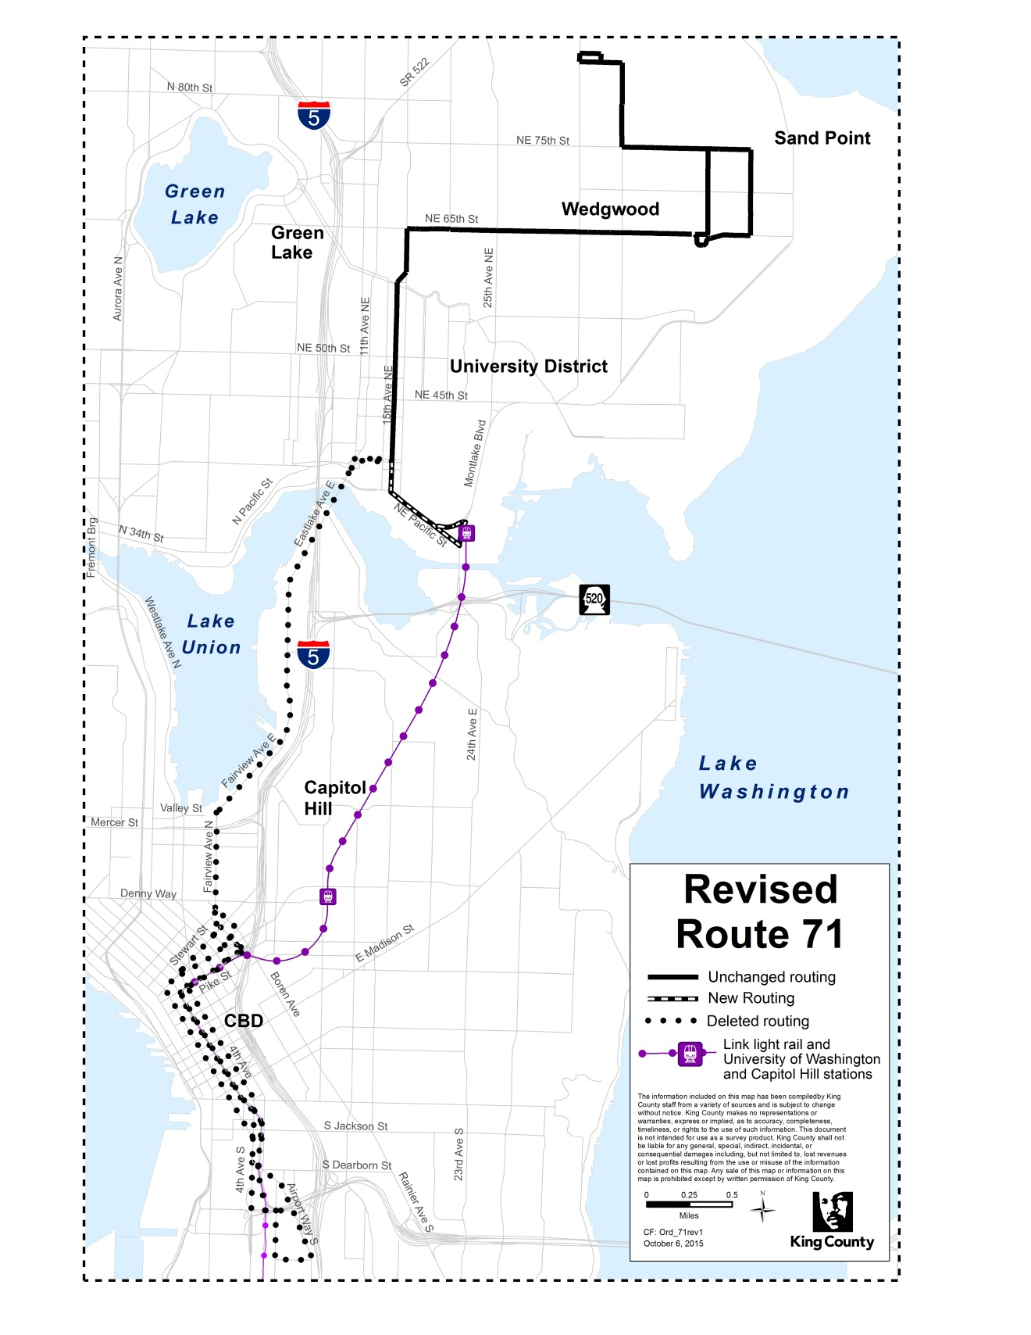
Delete pages 65, 66 and 67 pertaining to Route 73 and insert three new pages.

ROUTE: 73

OBJECTIVES:
Restructure and integrate service to complement the extension of Sound Transit Link light rail service to Capitol Hill and the University of Washington, in accordance with the Strategic Plan for Public Transportation, 2011-2021 and King County Metro Service Guidelines:

- Strategic Plan Strategy 3.1.1: Through investments and partnerships with regional organizations, local jurisdictions and the private sector, provide alternatives to driving alone.
- Strategic Plan Strategy 3.2.1: Expand services to accommodate the region's growing population and serve new transit markets.
- Strategic Plan Strategy 3.2.2: Coordinate and develop services and facilities with other providers to create an integrated and efficient regional transportation system.
- Strategic Plan Strategy 3.4.1: Serve centers and other areas of concentrated activity, consistent with Transportation 2040.
- Strategic Plan Strategy 5.1.1: Provide service that is easy to understand and use.

- Strategic Plan Strategy 6.1.1: Manage the transit system through service guidelines and performance measures.
  - Service Design Guideline – Routes should be designed in the context of the entire transportation system.
  - Service Design Guideline – A route that operates directly between two locations is faster and more attractive to riders than one that takes a long, circuitous path.
  - Service Design Guideline –Routes should serve connection points where riders can connect to frequent services, opening up the widest possible range of travel options.
  - Service Design Guideline – Routes are more efficient when designed to serve multiple purposes and destinations rather than specialized travel demands.

IMPACTED SERVICE AREA:
Jackson Park, Pinehurst, Maple Leaf, Roosevelt, University District, Seattle CBD

SERVICE CHANGE:

Revise Route 73 to operate between Jackson Park and the University District. Revise Route 73 to serve Northeast Pacific Street to connect to the new University of Washington light rail station. Route 73 will operate about every 30 minutes between about 6:00 a.m. and 10:00 p.m. on weekdays and between 7:00 a.m. and 10:00 p.m. on Saturdays. During the morning peak period, Route 73 will operate in the northbound direction only. In the afternoon peak period, Route 73 will operate in the southbound direction only. Delete Sunday service.

Link light rail, Routes 49 and 70 and revised Route 74X will provide alternative service between the University District and downtown Seattle. Route 373X will provide alternative service between Jackson Park and the University District during peak periods in the direction Route 73 is not operating.

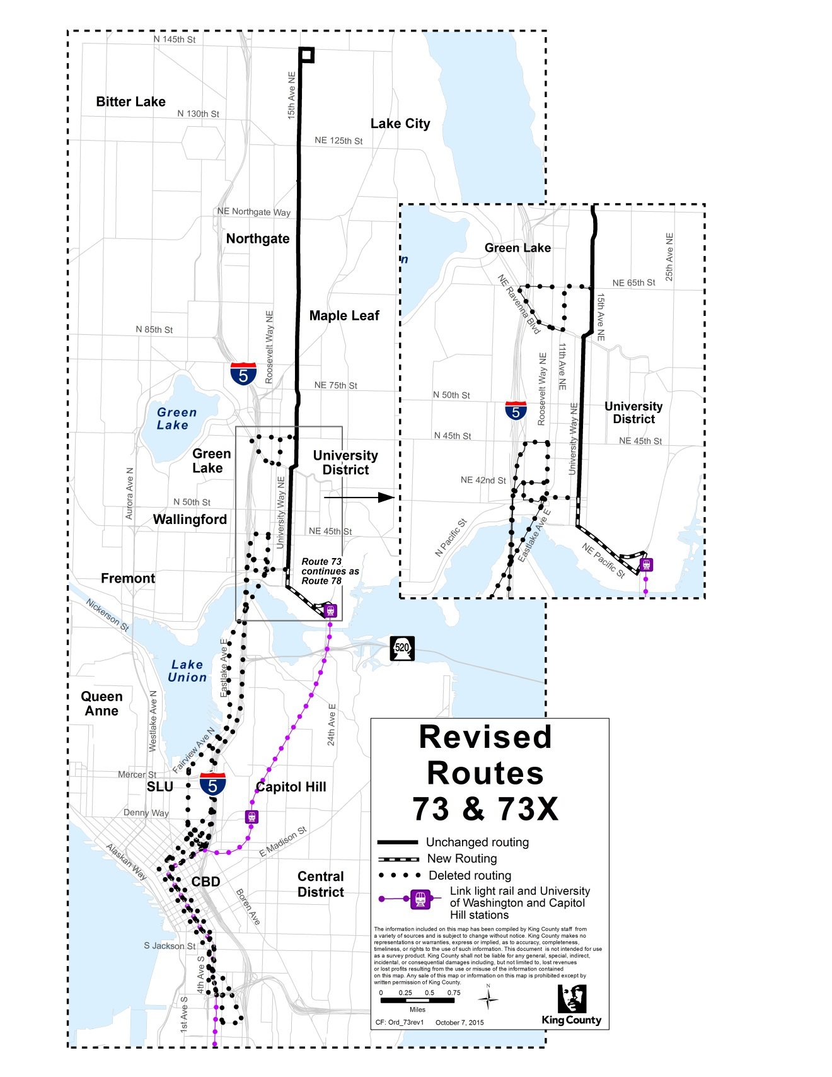

Delete pages 73 and 74 pertaining to Route 76 and insert two new pages.
ROUTE: 76

OBJECTIVES:
Restructure and integrate service to complement the extension of Sound Transit Link light rail service to Capitol Hill and the University of Washington, in accordance with the Strategic Plan for Public Transportation, 2011-2021 and King County Metro Service Guidelines:

- Strategic Plan Strategy 3.1.1: Through investments and partnerships with regional organizations, local jurisdictions and the private sector, provide alternatives to driving alone.
- Strategic Plan Strategy 3.2.1: Expand services to accommodate the region's growing population and serve new transit markets.
- Strategic Plan Strategy 3.2.2: Coordinate and develop services and facilities with other providers to create an integrated and efficient regional transportation system.
- Strategic Plan Strategy 3.4.1: Serve centers and other areas of concentrated activity, consistent with Transportation 2040.
- Strategic Plan Strategy 5.1.1: Provide service that is easy to understand and use.

- Strategic Plan Strategy 6.1.1: Manage the transit system through service guidelines and performance measures.
  - Service Design Guideline – Routes should be designed in the context of the entire transportation system.
  - Service Design Guideline – A route that operates directly between two locations is faster and more attractive to riders than one that takes a long, circuitous path.
  - Service Design Guideline –Routes should serve connection points where riders can connect to frequent services, opening up the widest possible range of travel options.
  - Service Design Guideline – Routes are more efficient when designed to serve multiple purposes and destinations rather than specialized travel demands.

IMPACTED SERVICE AREA:
Wedgwood, View Ridge, Ravenna, Seattle CBD
SERVICE CHANGE:

Improve service by extending the hours of operation such that trips will arrive in downtown Seattle between about 5:30 a.m. and 10:30 a.m. and depart downtown Seattle between about 2:15 p.m. and 7:30 p.m. Improve frequency by adding three trips in each direction during standard peak periods (6 a.m. to 9 a.m. and 3 p.m. to 6 p.m.).
Delete pages 75, 76 and 77 pertaining to Route 78 and insert three new pages.

ROUTE: 78

OBJECTIVES:
Restructure and integrate service to complement the extension of Sound Transit Link light rail service to Capitol Hill and the University of Washington, in accordance with the Strategic Plan for Public Transportation, 2011-2021 and King County Metro Service Guidelines:

- Strategic Plan Strategy 3.1.1: Through investments and partnerships with regional organizations, local jurisdictions and the private sector, provide alternatives to driving alone.
- Strategic Plan Strategy 3.2.1: Expand services to accommodate the region's growing population and serve new transit markets.
- Strategic Plan Strategy 3.2.2: Coordinate and develop services and facilities with other providers to create an integrated and efficient regional transportation system.
- Strategic Plan Strategy 3.4.1: Serve centers and other areas of concentrated activity, consistent with Transportation 2040.
- Strategic Plan Strategy 5.1.1: Provide service that is easy to understand and use.

- Strategic Plan Strategy 6.1.1: Manage the transit system through service guidelines and performance measures.
  - Service Design Guideline – Routes should be designed in the context of the entire transportation system.
  - Service Design Guideline – A route that operates directly between two locations is faster and more attractive to riders than one that takes a long, circuitous path.
  - Service Design Guideline –Routes should serve connection points where riders can connect to frequent services, opening up the widest possible range of travel options.
  - Service Design Guideline – Routes are more efficient when designed to serve multiple purposes and destinations rather than specialized travel demands.

IMPACTED SERVICE AREA:
Laurelhurst, University District
SERVICE CHANGE:

Implement new Route 78, which will provide service between Laurelhurst and the University District. Route 78 will operate about every 30 minutes from approximately 6:00 a.m. until 6:00 p.m. on weekdays only.

The Route 78 may not serve a bus stop on the east side of Montlake Boulevard NE within one-half mile of the University of Washington light rail station until the Council has adopted a motion approving the report referenced in Section 5 of this ordinance.

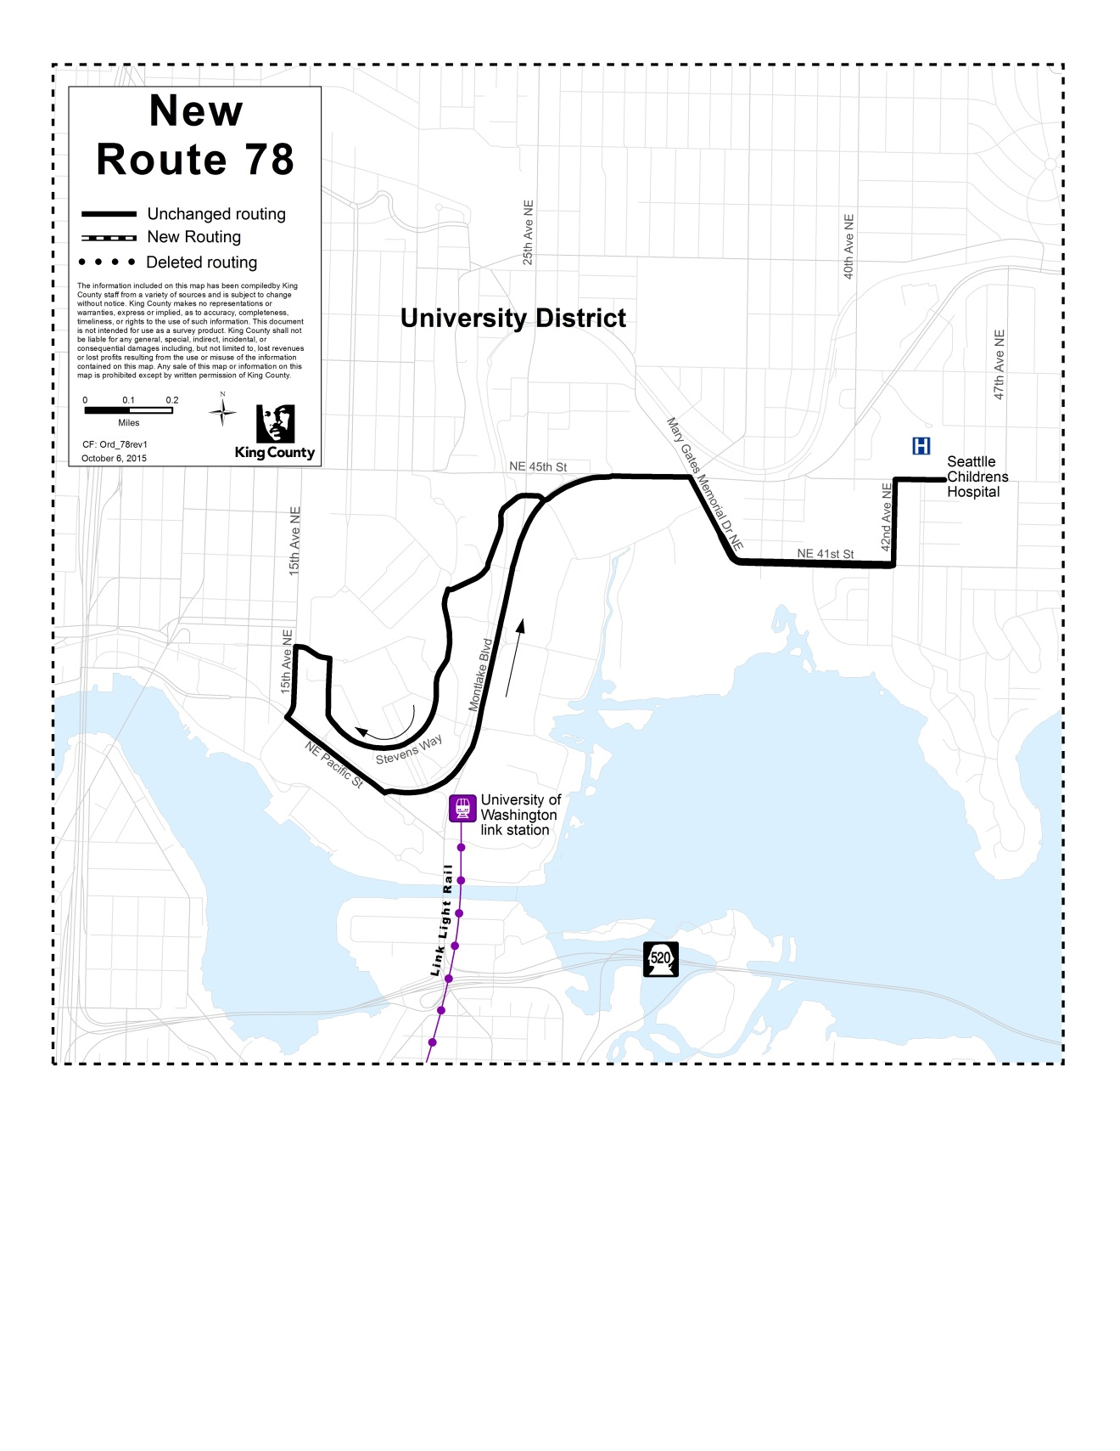
Delete pages 81 and 82 pertaining to Route 316 and insert two new pages.
ROUTE: 316

OBJECTIVES:
Restructure and integrate service to complement the extension of Sound Transit Link light rail service to Capitol Hill and the University of Washington, in accordance with the Strategic Plan for Public Transportation, 2011-2021 and King County Metro Service Guidelines:

- Strategic Plan Strategy 3.1.1: Through investments and partnerships with regional organizations, local jurisdictions and the private sector, provide alternatives to driving alone.
- Strategic Plan Strategy 3.2.1: Expand services to accommodate the region's growing population and serve new transit markets.
- Strategic Plan Strategy 3.2.2: Coordinate and develop services and facilities with other providers to create an integrated and efficient regional transportation system.
- Strategic Plan Strategy 3.4.1: Serve centers and other areas of concentrated activity, consistent with Transportation 2040.
- Strategic Plan Strategy 5.1.1: Provide service that is easy to understand and use.

- Strategic Plan Strategy 6.1.1: Manage the transit system through service guidelines and performance measures.
  - Service Design Guideline – Routes should be designed in the context of the entire transportation system.
  - Service Design Guideline – A route that operates directly between two locations is faster and more attractive to riders than one that takes a long, circuitous path.
  - Service Design Guideline –Routes should serve connection points where riders can connect to frequent services, opening up the widest possible range of travel options.
  - Service Design Guideline – Routes are more efficient when designed to serve multiple purposes and destinations rather than specialized travel demands.

IMPACTED SERVICE AREA:
Meridian Park, Haller Lake, Northgate, Green Lake, Seattle CBD
SERVICE CHANGE:

Improve service by adding up to five trips on weekdays during the peak periods.

Insert Attachment B, Key Transfer Locations.
EFFECT: Adds sections requiring the executive to report on (1) a joint King County-Sound Transit-Seattle work plan to improve locations where transfers are expected to increase, (2) a joint public engagement campaign to inform the public about the service change and ORCA card usage opportunities, and (3) an evaluation of before and after ridership and customer attitudes on Metro bus routes, coordinated with Sound Transit evaluation of Link Light Rail impacts with reports in 2017 and 2019. Also adds a section prohibiting a new bus stop on Montlake at Hec Edmundson until the Executive has provided and the Council has approved a study of traffic impacts of such a stop.
Amends Attachment A, the description of bus route changes, to correct minor wording errors and to modify the proposed changes to routes 43, 65, 67X, 71, 73, 76, 78, and 316.
Adds Attachment B, a map showing key transfer locations.

